CONTACT US:

Click here for instruction file

STORY HEADLINE 1
HARDWARE NEWSLETTER  At any time, you can easily change the text of any section in this document by simply clicking and typing. The template is prepared so that formatting stays in tact with the new information you include.  To update formatting, from the Home tab, you can use the Quick Styles gallery for the built in styles. You can also format text directly by using the other controls on the Home tab. | On the Design tab, you can change the theme, the colors, and the fonts of the document. This will update the entire document to the main color scheme and font scheme that you pick, with the click of a button!  To change any of the images, simply click on them and choose “Change Picture” from the Picture Tool tab. For the image on the first page, double click in the header to access the image and update it as necessry. | STORY HEADLINE 2  Type a quote from the story or the summary of an interesting point. You can change the color of the block automatically with a change of the template colors or update the fill of this cell.  For this side panel, include a few highlights for another story or some type of event you want to highlight.  Share with the audience what else is further in the document.  You can start a story here and continue it on another page in the newsletter if it pushes longer than this space allows.  Make the newsletter your own!
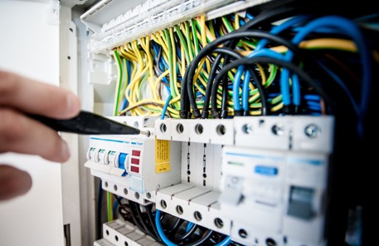
EMAIL | PHONE | LINKEDIN | TWITTER HANDLE

Click here for instruction file
THE NEWS LETTER SAMPLE
STORY HEADLINE 3
Include a highlight of your story here. You can put a tagline, start the story, or include a secondary headline to explain to the readers what this story is about in just a sentence or two.
You can easily change the formatting of selected text in the document by choosing a style from the Quick Styles gallery on the Home tab. If you want to change the fonts altogether, just go to the Design tab and select the font combination that you want for your headings and body text.  Also on the Design tab, you can change the color scheme of the document by picking a set of colors from the Colors menu.  Formatting makes text to jump off the page.  Consider:  - Interesting and relevant information. | Want to change up the images in the document? That’s easy! Simply click on any of the images and go to the Picture Tools tab. From there, click on the option to Change Picture. You will then need to selct the image you wish to be put in its place. Sometimes we use mathematical expressions for example x²+2logx and 2log₁₀(x)+4log₁₀(y) as images.  To update the images in the background of the document, you just need to double click in the header to access those images. The steps to changing them out are just as described above.  Type a quote from the document or the summary of an interesting point.  Images play important role in conveying a newsletter story.  Consider:Supportive images.
 |  | 
Company Name | Company Address | Phone Number | Email Address | Website address

